**TRAVEL MANAGEMENT SYSTEM**

**Table of Contents**

Introduction 3

Problem Scenario 3

Project Objectives 3

Functional Requirements 4

System Architecture 5

Implementation Details 6

Demo and User Interaction 9

Future Enhancements 11

Conclusion 11

References 13

# Introduction

The Travel Management System exercise offers a reliable solution to the indication of trouble that Solent Trips, a fictional travel company, faces in its paper based administration system. The project will attempt to simplify the communication, minimize the documentation, and to aggregate trip management procedures by means of the virtual solution. The purpose of this paper is to give a deeper insight into the issues encountered by Solent Trips, and to show why a digital transformation is crucial. And especially provides a summary of report structure, which outlines the main parts discussed so far. Through assessing the specified functional requirements, system architecture, implementation details, user interaction, and further areas for improvement, it is intended to enable a deep-rooted understanding of the Travel Management System project that will lead to increased efficiency and effectiveness within Solent Trips. The Travel Management System project is tackling this change by means of joint teamwork and developing a new level of executive examples.

# Problem Scenario

The imaginary travel agency, Solent Trips, at the moment has prominent issues correlated to its paper-based management system (Yu and Yuan, 2022). Manual processes contain inside them many inefficiencies such as way too much of paperwork, lack of communication channels, as well as dispersed data management. Such obstacles lead to reduce the performance level of the operation and to deteriorate the customers' experience. Realizing the importance of digital transformation and modernization, the Travel Management System project agenda is built to resolve those problems broadly. The main objective of the project to be undertaken is to replace paper-based system of Solent Trips with online solution which will bring in streamlining communication, reducing paperwork and centralizing trip management process. Through the digital platform of Solent Trips, the supply system is made smarter, administrative processes are minimized, and ultimately customer satisfaction is improved.

# Project Objectives

* To streamline communication between staff and travellers by implementing a centralized platform, thereby eliminating communication bottlenecks and improving information dissemination.
* To reduce the reliance on manual paperwork by digitizing trip management processes, leading to increased operational efficiency and decreased administrative overhead.
* To centralize all aspects of trip management, including trip creation, traveller management, trip leg management, and reporting and analytics, within a single platform.

# Functional Requirements

The Travel Management System Project which is a collection of functional requirements was in the making so as to meet the diverse needs of the organization as well as its stakeholders. The requirements cover key aspects such as trip management, traveller management, and other administrative tasks in order to improve the functioning of the system. The application needs to have trip management features such as the registration, viewing, updating and deletion of trips (Ghiani *et al.* 2022). Crucial trip details such as name, date of commencement, length of stay, and contact information should be defined to facilitate accurate trip planning and coordination within the system. Frequent traveler management functions are needed to collect and work with key traveler information during this process. The system required is one that allows for creating, viewing, editing, and deleting traveller profiles, thus Solent Trips can maintain accurate records of travellers' personal details, like their name, physical address, date of birth, and emergency contacts. Trip leg management functionalities enable trip planning using starting location, destination, mode of transportation, provider and cost as parameters. The platform must guarantee different kinds of trip legs like accommodations, points of interest, and transfer points, allowing people to plan their trips according to their circumstances perfectly. The system must generate a set of functionalities, depending on different user roles inside Solent Trips (Martin *et al.* 2023). We have established three positions: Trip Coordinator, Trip Manager, and Administrator, with each of the employees having tasks that are related to trip management, passenger handling, invoice generation, and reporting. In order to do this, the system must include reporting and analytics functionalities that would allow administrators and managers to generate reports on all aspects of trip performance from financial summaries to traveller statistics. Integration of Python libraries such as Matplotlib or Plotly for data visualization will facilitate information analysis aimed at making well-informed decisions.

The functional necessities of the Travel Management System project serve to take care of the different needs of Solent Trips including trip management, traveller management, user roles, and reporting functionalities all as well to increase operations efficiency and consequently improve the customer experience.

# System Architecture

Through Solent Trips Travel Administration System is engineered with modular nature in order to achieve flexibility, scalability, and efficiency during its operation. Comprising 4 main components being trips, travellers, trip legs and user roles, it follows the modular approach which gives it a flexible quality and this makes interactions between different modules easier (Zhang *et al.* 2022). At its core, the system design is defined by the set of interfaces that are specified and which make the work of synchronized modules possible. The modular design, promoting reusable code, ease with maintenance and future improvements is without the need of redefining the system from scratch. The scalability of the system architecture is an important requirement, which enable developers to consistently improve the product and add more features without much disruption to existing components.

This flexibility allows Travel Management System to change according to business demands and to address the whole range and variety of cases of its application. The modular architecture of the app has flexibility of users to design its deployment structures according to particular trip types, roles, and workflow conditions. Through configurability, Solent Trips has the advantage of adapting its system architecture design in order to meet its particular operational needs and preferences, which in turn increases its operational efficiency as well as customer experience.

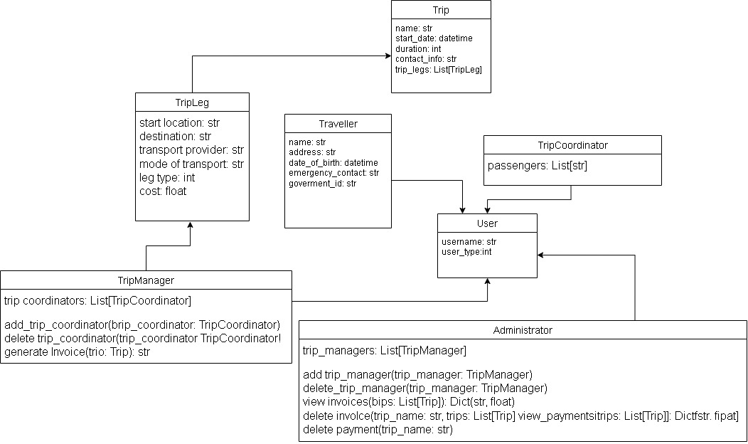

**Figure 1: System architecture in detail**

(Source: Self-created)

The system structure that designs passenger trips. It involves three main entities: drivers, passengers, trip coordinators, and a trip manager. Travelers submit trip information, including date of departure, duration and contact data. Humanize the sentence: Trip coordinations involve responsibility of trip legs which include starting point, destination, transport provider, and type of travel. The trip manager will produce invoices and manage and coordinate the trip managers and users.

In general, the architecture of the Solent Trips Travel Management System is modular, scalable, and flexible; key components are built on well defined interfaces and modules. This architecture forms a good basis for the system’s performance, making it possible for the system to thrive and to cope with all the changes propelled by the needs of the project and its stakeholders.

# Implementation Details

The Travel Management System (TMS) for Solent Trips implementation implies the use of Python programming language (Python) and multiple libraries to code a functional software solution that covers all detected functions requirements (Sun, 2020). The implementation includes the industry's best practices for software development, following the principles of modulurity, code reuseability, and maintainabilty.

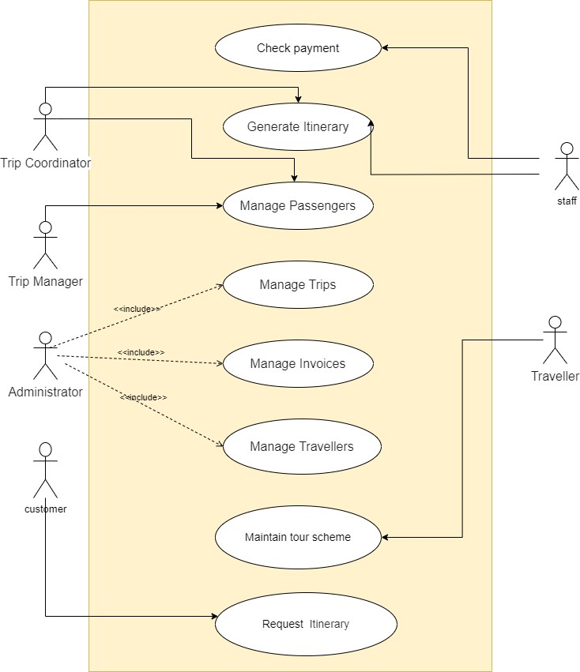

**Figure 2: Class Diagram**

(Source: Self-created)

This architecture enables and assures the role-based approach of passenger trip management. The travelers manage their accounts and book their trips whereas the Trip Organizers create schedules. Trip Coordinators are involved in the minutiae of each trip phase. Passengers management and the trips fall within role of the Trip Manager. The last, Administrators take care of managing user account and invoices. This distributed structure ensures appropriateness of the trip management by assigning specials tasks to the certain positions in the group.

TMS implementation will be based on PyCharm, an IDE that aiding in Python development with its powerful tools and features (Liu *et al.* 2021). Python 3.8+ is considered as it is easy to understand, highly readable, and has abundant packages.

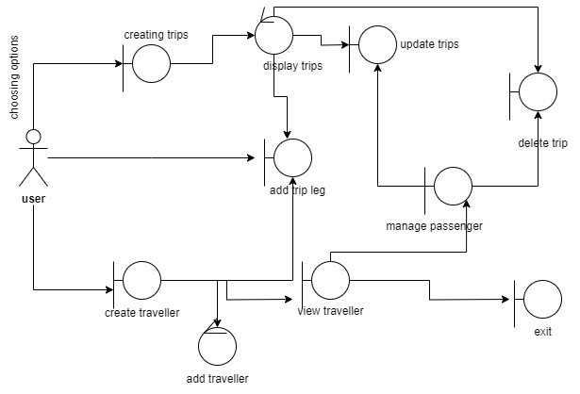

**Figure 3: Robustness diagram**

(Source: Self-created)

The system is designed using double-layered user structure with regard to trip management. Trip Coordinators are the most authorised people. They are able to create and administrate itineraries, manage passenger information and invoices. In fact, they develop an itinerary and carry out the whole trip management process. On the other hand, Users have restricted sets of tasks to do. They can look at the list of tours, get registered for the system, and sign in. It means a precise separation of authority within the trip organization system.

The TMS implementation is composed of libraries and modules that operate over various functionalities. The `csv` library is used for importing and exporting the information about the trip and the travellers in CSV files. The `datetime` library is used for date and time handling, being able to provide the exact monitoring and handling of the trip schedules. Along with that, `json` library is used for the manipulation of JSON files, that provides a flexible and lightweight format of data inter-conversion. For TMS implementation, two options are available, including the console-based user interface (UI) and graphical user interface (GUI). The console interface is lighter, snappier, and also simpler to use compared to the GUI, which is developed via the `tkinter` library and affords a more engaging and visual user experience. Version control is carried out using Git Tools and GitHub which allows the team to collaboratively develop the product. Version tracking is also made possible (Wulff *et al.* 2021). Whether hosting the Git repos on GitHub or not, the TMS implementation will always ensure a developmental history and ease of collaboration between the team members. The implementation methodology covers the ICONIX process, which is a software development methodology that promotes iterative design, user feedback, and system testing. This approach is to make sure that the TMS implementation achieves its purpose satisfactorily and to the performance (Alhassan and Sevtsuk, 2024). The structural design of our TMS system is modular. It consists of several modules for trip management, passenger management, trip legs, and user roles. This modular construct facilitates code reusability, scalability and flexibility, which makes it easier for the new features and functionalities to be integrated into it.

Primarily, in terms of design and implementation of TMS for Solent Trips, the process is managed in line with industry best practices and standards, thereby making use of the Python language and libraries to deliver a powerful and easy-to-use software program. Adherence to the modularity principles, code quality and iterative development along with TMS implementation will be to the purpose of Solent Trips needs and will definitely improve the operational proficiency and customer satisfaction.

# Demo and User Interaction

The Travel Management System (TMS) for Solent Trips demonstration involves sharing the system's maximum functionalities and user interactions. Throughout the session, users are led via different tasks or processes to demonstrate the system's capacity and simplicity (Tang *et al.* 2022). To initiate the demo, users are presented with a menu of options, which they can choose from to complete various activities such as creating or viewing trips and travellers, updating or deleting trips, generate invoices, and also to perform administrative tasks. Each variant of TMS is assigned to its separate function which is further processed by users in accordance to their roles and requirement. A clear example of this would be for people to select an option to create a new trip, followed by the input of trip details, including the trip name, trip start date, duration and contact information.

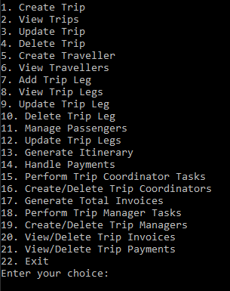

**Figure 4: Demo Implementation**

(Source: Implemented in PyCharm)

In addition, users can add their own profiles using their names, addresses, birth dates and emergency contact numbers. When users start using this system they communicate with it through the user friendly interface, which is console based or graphical according to the preferences of users. The interface includes instructions that are very captivating and guide users through every step of the process. The interface was designed to be effortless and simple to use. As users move through the system, they will be able to see, update, and erase trip and traveller records, create or remove trip legs, manage passengers, chart itineraries, handle payments, and even perform important tasks such as creating user roles and generating total invoices. What the demo is going to show are the systems reporting and analytics functions, determining how the administrators and managers can get information from trip performance, financial summaries, and traveller statistics using python libraries such as Matplotlib or Plotly (Farrag *et al.* 2021). Such reports are crucial in shaping the planning and weighing the performance, to leave all users fully informed and able to effectively manage the trip planning process.

Demonstration and user experience validate that the TMS of Solent Trips has a wide range of functionality, simplicity to use, and it increases the efficiency of the travel management processes further and allows for user satisfaction.

# Future Enhancements

The concept of the Travel Management System (TMS) for Solent Trips offers great prospects for advancements in the future and it helps the travel agency to meet its needs and become more productive. To guarantee better user experience and achieve a smooth communication, it is of paramount significance to introduce a notification system. This system would make it possible to send passengers notifications and other timely updates regarding their means of travel and allow them to stay informed while journeying (Huang *et al.* 2021). The feedback feature, another crucial component of the TMS, will give travellers the opportunity to express their opinions and provide suggestions. This will facilitate the process of gathering constitutent insights, which will aid the company in continuously improving the trip experience based on the feedback provided by travellers. Geolocation technology can be used to provide location-based tips on the best activities and navigation methods that enhance the passenger's travel experience. Through a service tailored to individuals’ current location, Solent Trips would find ways to enhance customer satisfaction and make travel feel more personalized and coherent. A third major area that needs to be improved is the reporting and dashboard capabilities of the TMS. Using these advanced analytical and predictive instruments, managers and directors will obtain more valuable information regarding trips' performance, financial trends and traveller's behaviour and they be able to make more relevant decisions in order to apply best practices to enhance trip management practices.

# Conclusion

The Travel Management System that has been created for Solent trips is a remarkable step towards cutting-edge modernization and improving service delivery. Through digitalizing the core operations and launching a unique tool that encompasses the whole trip management process, the system helps to improve the user experience, communication, and informed decision making. The next step is to look forward into improvements such as communication, feedback from the customers, geolocation technology, and reporting capabilities which will improve trip management and make traveling an exciting experience for the passengers. Through the process of constant improvement and development, we gain the agility required to adjust to the dynamics of changes while embracing new technologies, therefore maintaining our edge in the travel market. With Travel Management System, the digital solutions are proved to be efficient in transforming old routines and generating novel services.

# References

Yu, Q. and Yuan, J., 2022. TransBigData: A Python package for transportation spatio-temporal

big data processing, analysis and visualization. Journal of Open Source Software, 7(71), p.4021.

Martin, H., Hong, Y., Wiedemann, N., Bucher, D. and Raubal, M., 2023. Trackintel: An open-

source Python library for human mobility analysis. Computers, Environment and Urban Systems,

101, p.101938.

Ghiani, G., Laporte, G. and Musmanno, R., 2022. Introduction to Logistics Systems

Management: With Microsoft Excel and Python Examples. John Wiley &amp; Sons.

Zhang, S.N., Li, Y.Q., Ruan, W.Q. and Liu, C.H., 2022. Would you enjoy virtual travel? The

characteristics and causes of virtual tourists’ sentiment under the influence of the COVID-19

pandemic. Tourism management, 88, p.104429.

Sun, G., 2020. Symmetry analysis in analyzing cognitive and emotional attitudes for tourism

consumers by applying artificial intelligence python technology. Symmetry, 12(4), p.606.

Liu, M.T., Liu, Y., Mo, Z. and Ng, K.L., 2021. Using text mining to track changes in travel

destination image: the case of Macau. Asia Pacific Journal of Marketing and Logistics, 33(2),

pp.371-393.

Wulff, N., Miorelli, F., Gils, H.C. and Jochem, P., 2021. Vehicle energy consumption in Python (VencoPy): Presenting and demonstrating an open-source tool to calculate electric vehicle

charging flexibility. Energies, 14(14), p.4349.

Alhassan, A. and Sevtsuk, A., 2024. Madina Python Package: Scalable Urban Network Analysis

for Modeling Pedestrian and Bicycle Trips in Cities. Available at SSRN 4748255.

Tang, H., Wu, Y., Cai, Y., Wang, F., Lin, Z. and Pei, Y., 2022. Design of power lithium battery

management system based on digital twin. Journal of Energy Storage, 47, p.103679.

Huang, W., Zhu, S. and Yao, X., 2021. Destination image recognition and emotion analysis:

evidence from user-generated content of online travel communities. The Computer Journal,

64(3), pp.296-304.

Farrag, S.G., Outay, F., Yasar, A.U.H., Janssens, D., Kochan, B. and Jabeur, N., 2021. Toward

the improvement of traffic incident management systems using Car2X technologies. Personal

and Ubiquitous Computing, 25, pp.163-176.